**Run Collection Remotely with URL**

**1. Create a collection and click on share to get URL**

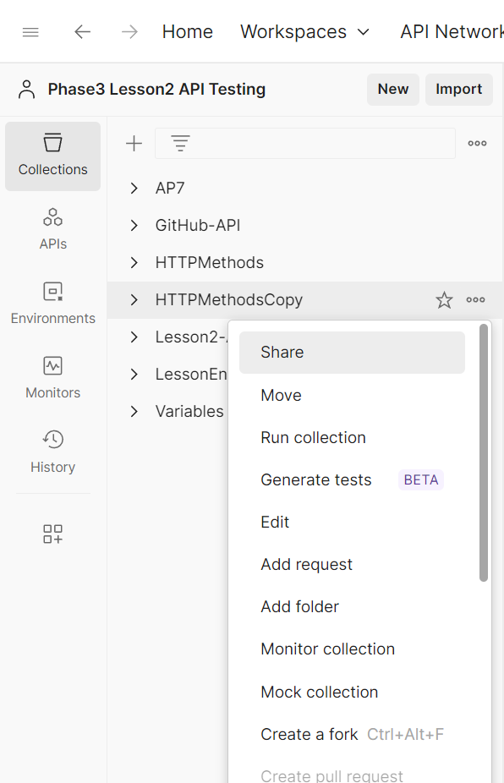

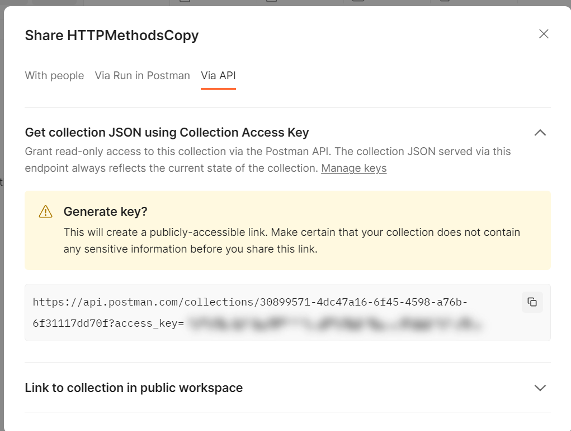

**2. Copy the URL and run via cmd prompt**

